# Tech Weeks

# Day 5 Task Sheet

**Instructions**

1. The task sheet contains the necessary resources and the assignment for the day.
2. You are given **24hrs.** to submit the assignment on the Google Classroom.
3. You must upload the **.html files** and the **screenshots of the final output on browser** you have developed, on the Google Classroom.
4. These files are to be uploaded in .zip
5. You must implement the assignment in such a way that all the requirements specified are met.
6. Read the assignment problem statement thoroughly and then start implementing it.

## Learning:

# Introduction to Bootstrap - <https://youtu.be/wesUO81YX0U>

# Installing Bootstrap the CDN way - <https://youtu.be/R52AsglN0DE>

# Installing Bootstrap Locally - <https://youtu.be/2W03ZymI46g>

# Bootstrap Grids - <https://youtu.be/g3LRU3JF-rQ>

# Using the grids - <https://youtu.be/e5VQampkqdg>

# Nested the grid - <https://youtu.be/x6uafDNy-F4>

# Push and pull - <https://youtu.be/6UgQYdhy8uU>

# Typography Classes - <https://youtu.be/dGAy2YlnR0g>

# Bootstrap Tables - <https://youtu.be/YnrEGDdJfSk>

# Bootstrap Images - <https://youtu.be/x99gNzHtm0k>

# Buttons - <https://youtu.be/VBKD5q7ohG4>

# Basic forms - <https://youtu.be/gl5rIDno7Ps>

# Horiziltal form - <https://youtu.be/KIaLq0uX3LY>

# List Group - <https://youtu.be/eLXBxyD-k2k>

# Jumbotorns and Wells - <https://youtu.be/44ILXbD7BnI>

# Dropdown - <https://youtu.be/Xjmhj76Jhhs>

# Navigation - <https://youtu.be/BuhwVphVFK4>

# Navbar - <https://youtu.be/15Yb9ZcCp3M>

# Collapse - <https://youtu.be/Fqgr2ePX51A>

# Carousel - <https://youtu.be/sivXk8cTPIA>

# Assignment –

# Create a navbar using bootstrap

# Create 2 buttons using bootstrap as shown in the screenshot

# Create bootstrap cards as shown in the screen shot

# Create Carousel using bootstrap

**Screen shot –**

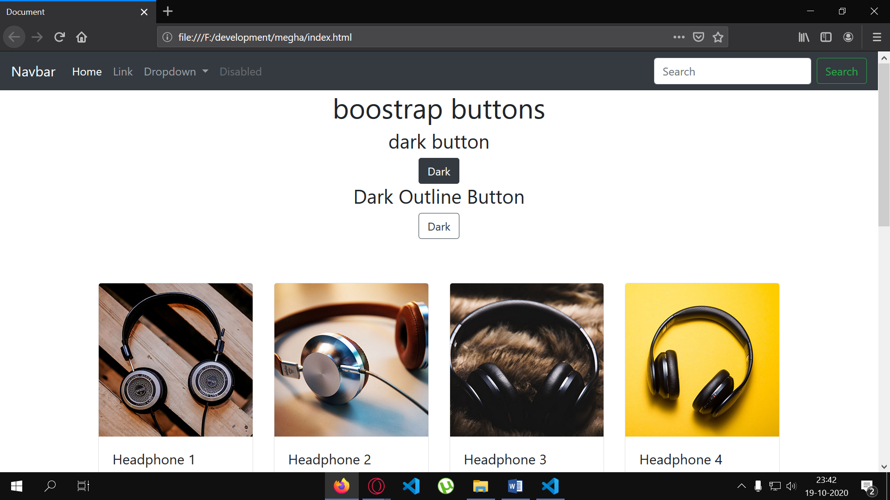

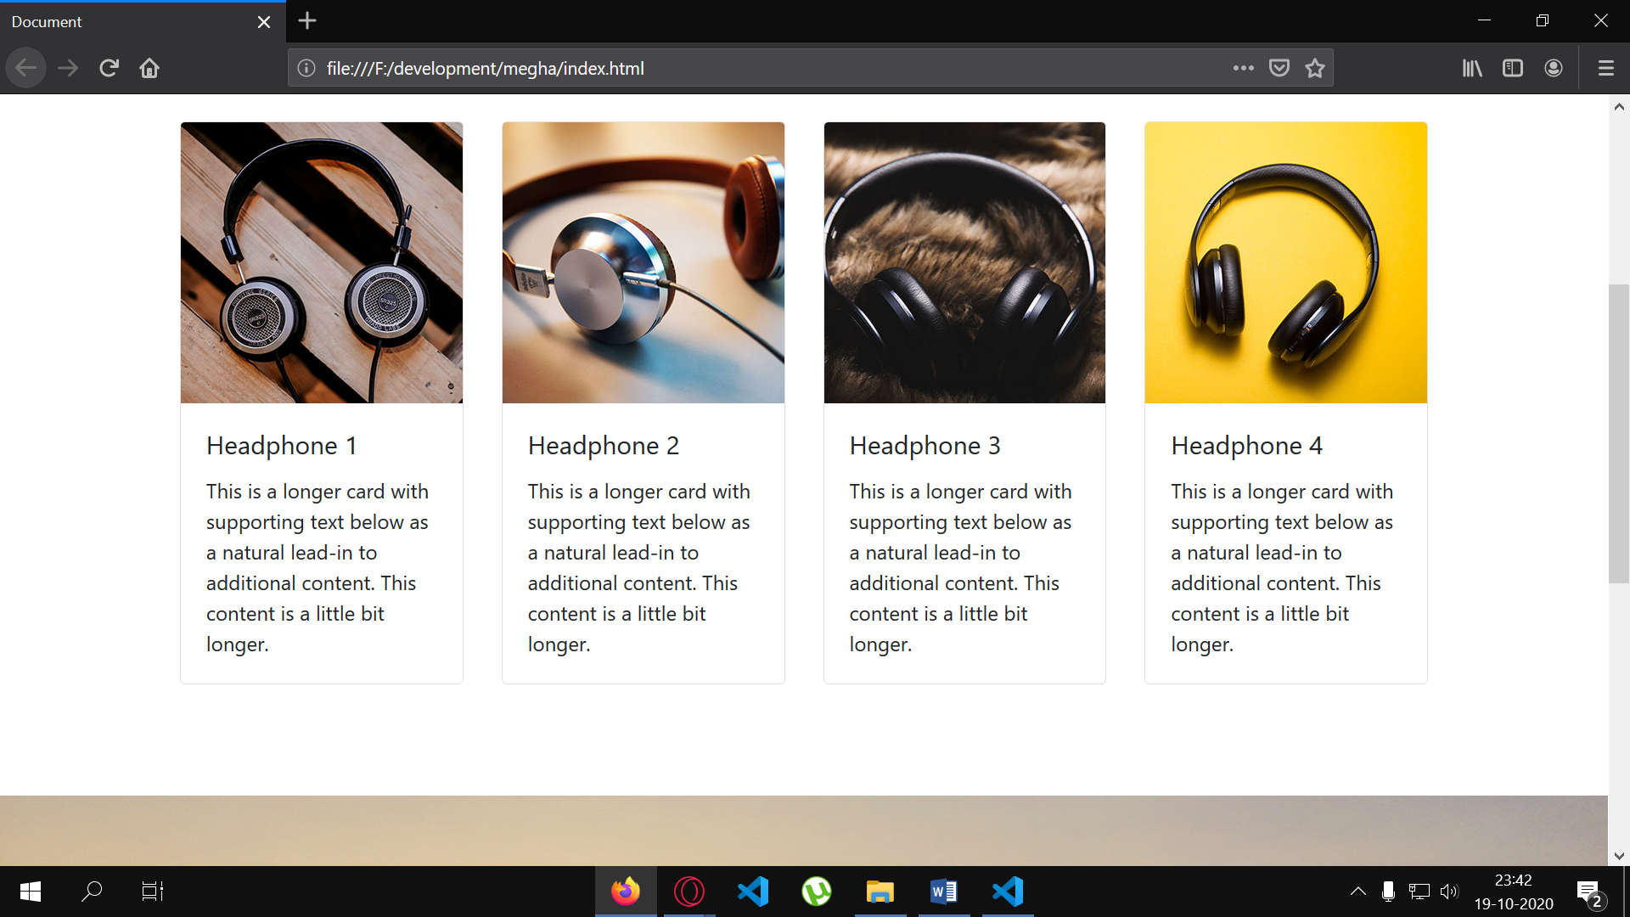

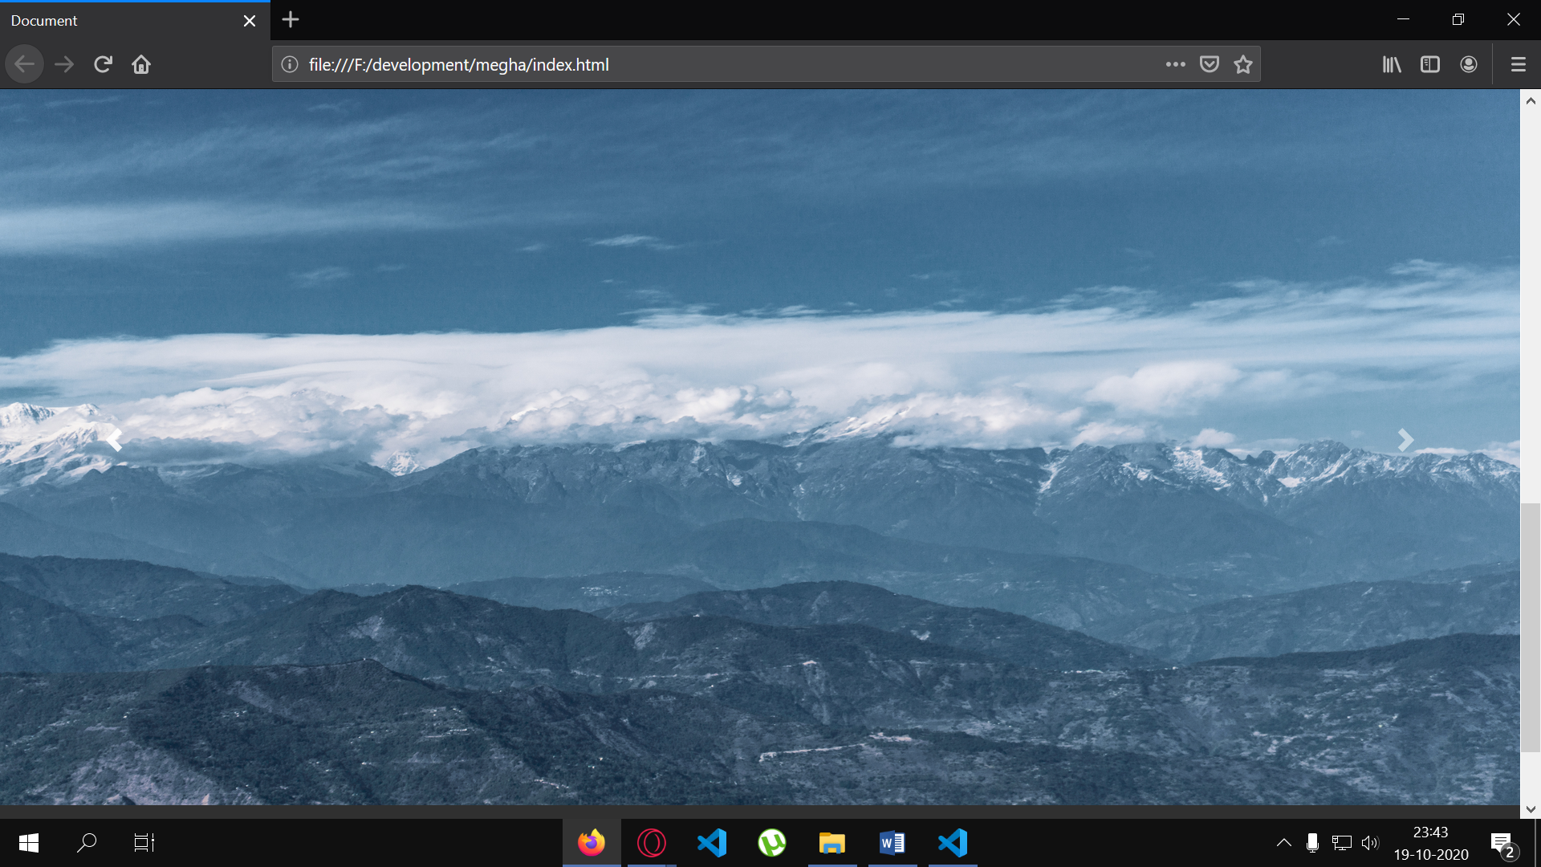

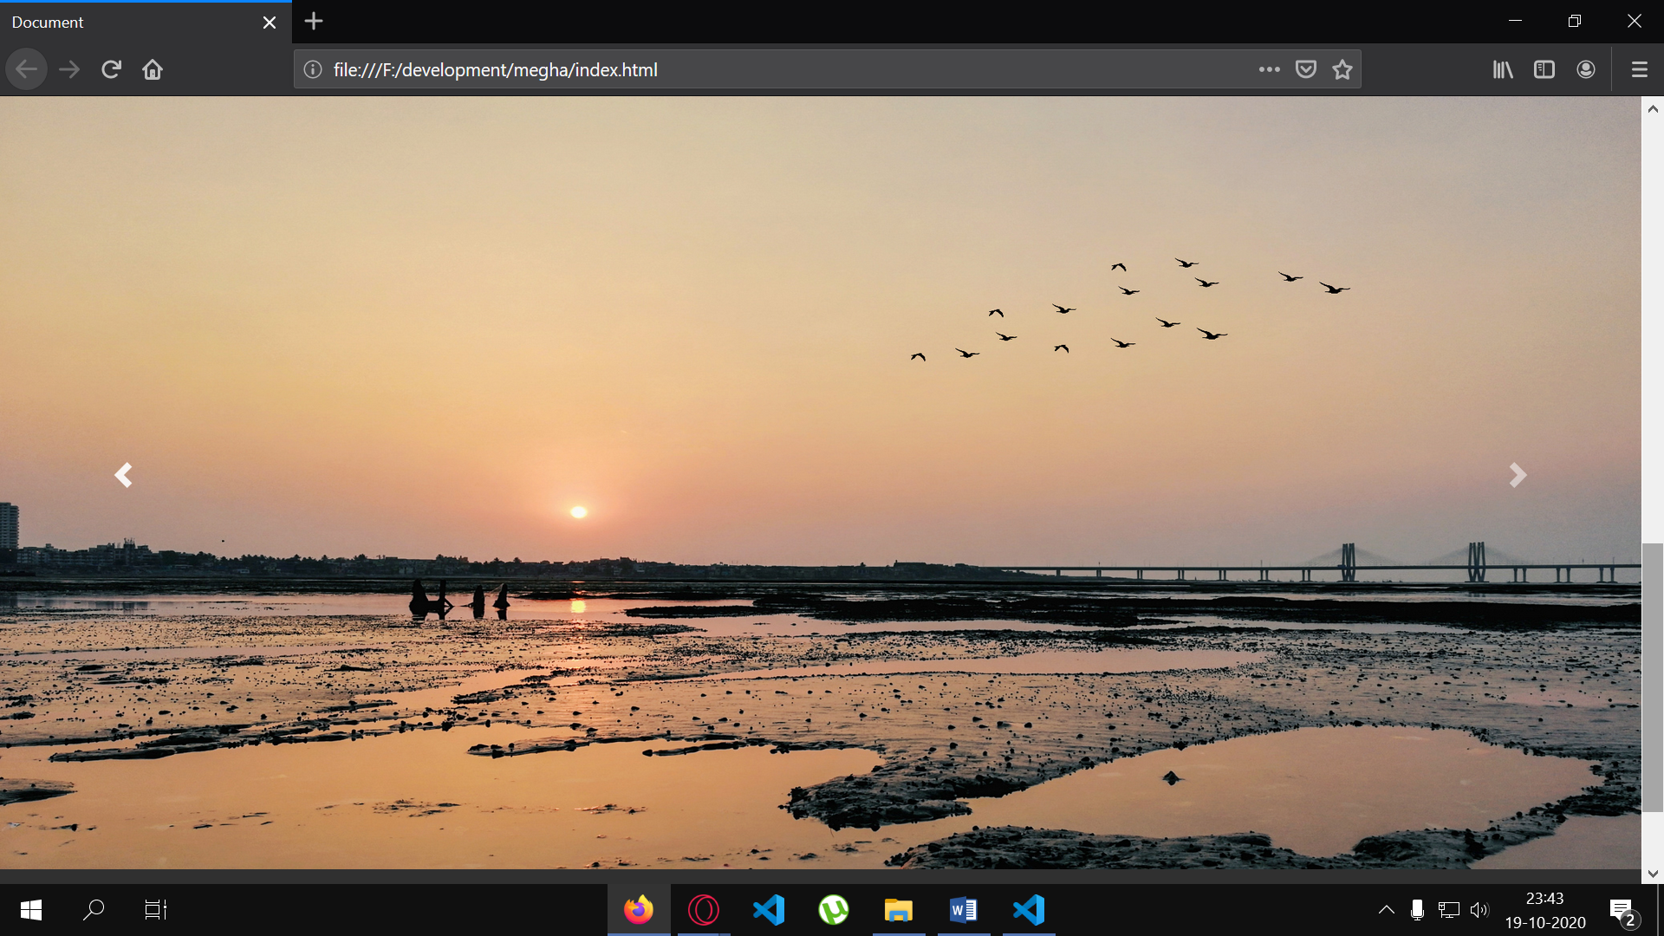

**Ps – I clicked those Photos(landscape)**